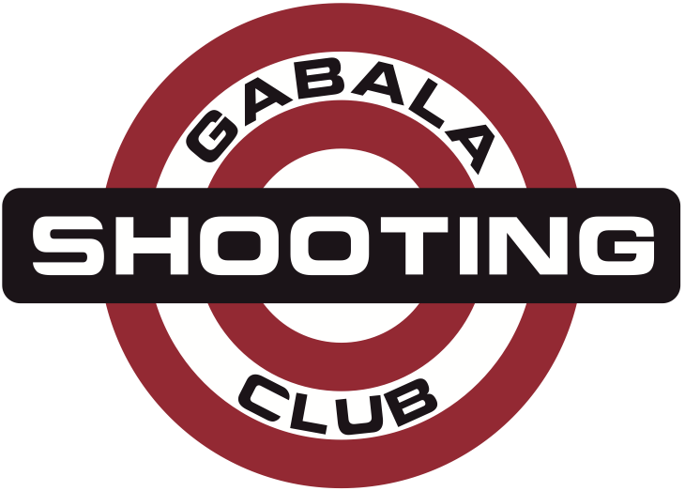
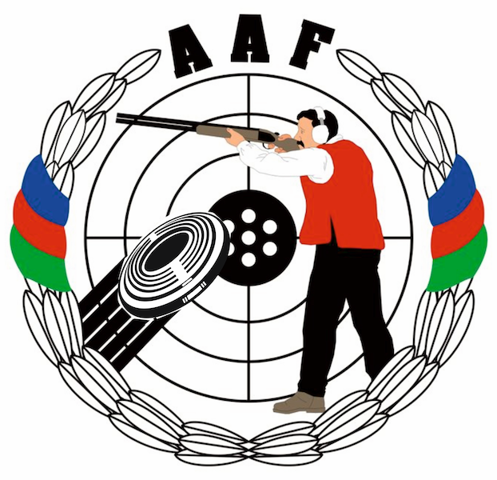
HEYDAR ALIYEV
INTERNATIONAL GRAND PRIX
Gabala, Azerbaijan
14 – 21 August 2014

Please email to Organizing Committee: info@gabala.eu
FINAL HOTEL RESERVATION FORM |  |  |  | Please return by |  | to Organizing Committee
name of federation |  |  |  | 15 July 2014 |  | Lermontov str. 68  Baku, AZ1066, Azerbaijan  Phone: +994-50-5141515  Phone: +994-55-7537775  E-mail: info@gabala.eu
hotel  choice | no |  | Please indicate the hotel in order of preference
hotel  choice | 1
hotel  choice | 2
hotel  choice | 3
room choice |  | room type |  | number of rooms | number of nights |  | day of arrival | day of departure
 |  | single
 |  | double/twin
 |  | triple
 |  | cottage
Note:

Date |  | Signature of Team Leader

